**TechConnect Pro Network Architecture Design**

**Name: Gopikrishna Mogilicharla**

**Github URL: https://github.com/gmogilicharla/Project**

**SQL environment (Windows)**

**TechConnect Pro**

**Object oriented model:**

The provided PlantUML code represents an Object-Oriented Model for a relational database schema. Here are a few points about the Object-Oriented Model:

1. **Classes Represent Tables:** Each class in the model corresponds to a table in the relational database. The attributes of the classes represent the columns in the respective tables.
2. **Associations Represent Relationships:** Associations between classes depict the relationships between tables. For example, the "WorksAt" association between **Employees** and **Locations** indicates the location where an employee works.
3. **Cardinalities:** The cardinalities (e.g., "1" or "0..1") on associations specify the relationship between entities. They define how many instances of one class are related to another.
4. **Directionality:** The **left to right direction** keyword sets the direction of the diagram from left to right, enhancing readability and conveying the flow of relationships.

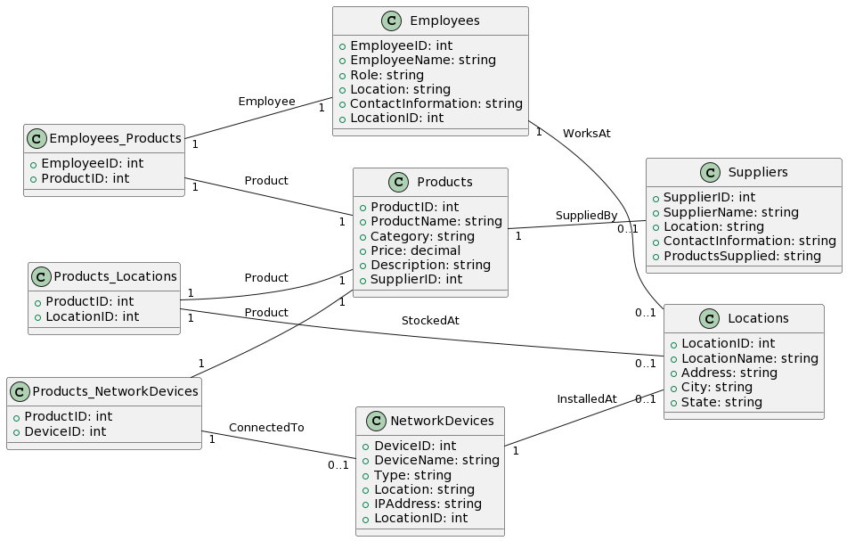

**Entity relationship Model**

As for the ERD (Entity-Relationship Diagram) model for the same database, an ERD typically represents entities, attributes, and relationships. Each table in the database corresponds to an entity, and the relationships between tables are depicted using various symbols such as lines and diamonds.

Key points about the ERD model for this database:

1. **Entities:** Entities in the ERD correspond to tables in the database. For example, **Employees**, **Locations**, **NetworkDevices**, etc., each represent an entity.
2. **Attributes:** Attributes of entities in the ERD represent the columns in the corresponding tables. For instance, attributes of the **Employees** entity include **EmployeeID**, **EmployeeName**, etc.
3. **Relationships:** Relationships in the ERD show how entities are connected. The lines connecting entities indicate relationships, and diamonds represent the cardinality of these relationships.
4. **Cardinalities:** Similar to the Object-Oriented Model, cardinalities in the ERD specifies how entities are related in terms of the number of instances.

Both the Object-Oriented Model and the ERD provide different perspectives on the structure and relationships within the database, catering to different modeling and design needs.

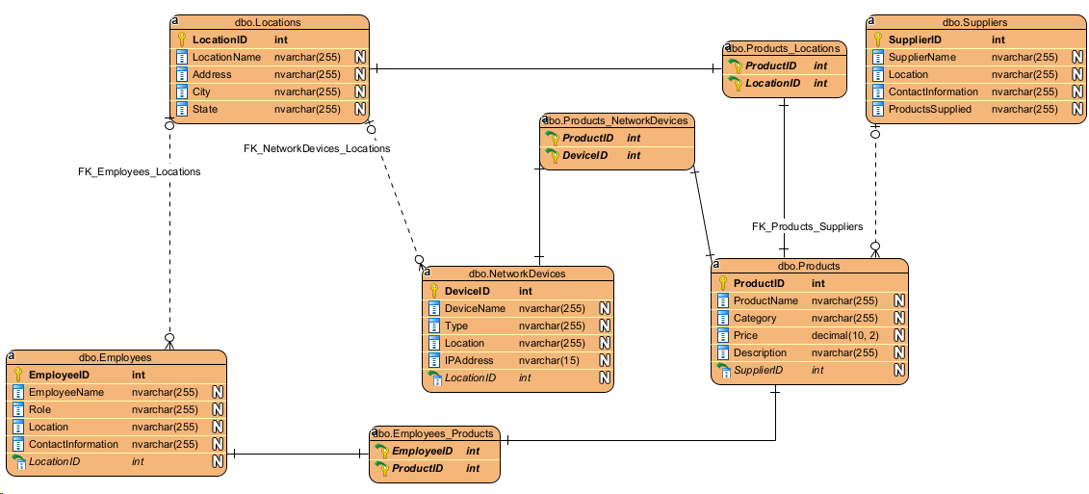

**Relationships among the entities:**

1. **Products and Suppliers:** Products are supplied by various Suppliers in a one-to-many relationship. Each product can have one supplier, but a supplier can supply multiple products.
2. **Suppliers and Locations:** Suppliers operate or are situated in various Locations in a many-to-one relationship. Multiple suppliers can be located in the same location, but each supplier belongs to one location.
3. **Employees and Locations:** Employees operate or are stationed in different Locations in a many-to-one relationship. Multiple employees can work in the same location, but each employee is associated with one location.
4. **Network Devices and Locations:** Network Devices are placed in specific Locations in a many-to-one relationship. Multiple network devices can be in the same location, but each device is placed in one location.
5. **Products and Network Devices:** Products may depend on certain Network Devices in a many-to-many relationship. A product might be associated with multiple network devices, and a network device might serve multiple products.
6. **Employees and Network Devices:** Employees utilize or manage various Network Devices in a many-to-many relationship. Multiple employees can use multiple devices, and a device can be accessed by multiple employees.
7. **Products and Employees:** Employees are involved in the handling or management of Products in a many-to-many relationship. Multiple employees can manage multiple products, and a product might be managed by multiple employees.
8. **Products and Locations:** Products are available or managed at various Locations in a many-to-many relationship. A product might be present or managed at multiple locations, and a location can have multiple products associated with it.

These relationships define how the entities within the system interact or rely on each other within the TechConnect Pro business model.